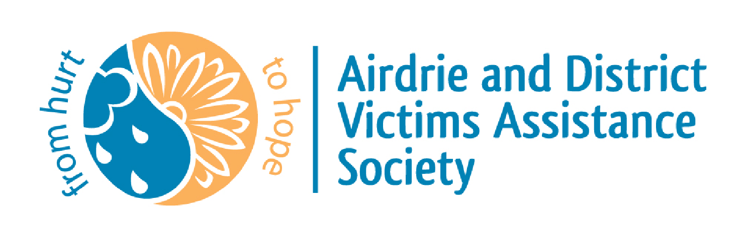

2023 Annual General Meeting
Submitted by Debbie Reid – Executive Director

2022 HIGHLIGHTS

ADVAS managed many changes that includes some new 2024 initiatives to our program and these will revise the services we provide to the communities we are privileged to support. As these changes continue to fluctuate, as the Alberta Government implements the program, ADVAS will continue to operate as usual. 2022 highlights included:
- An exemplary relationship with RCMP and other support agencies within our City and surrounding communities.
- The announcement of the proposed re-design was released in June 2022.
- Renaming of JSG to the “Alberta Public Safety & Emergency Services”.
- City of Airdrie extended their financial support of the Non-Criminal files.
- Board Member received the Queen Elizabeth II Platinum Jubilee Medal.
- Preparation to transition to paperless database January 1st, 2023.
- Restructuring of staff to include new Executive Director.
- Fund-raising casino.
- Collaborated with RCMP CRO’s (Community Resource Officers) and engaged in Restorative Practices training to be used in schools when interacting with students.

HUMAN RESOURCES

- The ADVAS Board is currently comprised of eight directors and three RCMP liaison officers.
- Nineteen Volunteer Crisis Advocates continue to support the Society, with three new recruits going through the stages of suitability & security clearances, and on-line training.
- A total of two full-time staff, one part-time staff and one on leave, make up the current paid staff of ADVAS.
- A volunteer Crisis Advocate took over the Non-Criminal Administration Support position while a staff member took a leave. She has grown in this role and created an efficient and successful position.
- The sitting Executive Director that was on leave, resigned, and an existing staff member applied for and accepted the role.
- A Volunteer Program Manager was recruited and hired and greatly improved the existing volunteer program that is currently in use.
- Cross training between all staff positions is ongoing.
- Advocate and staff training continues to be ongoing for 2023.
- Wellness of our Society is always foremost in the minds of ADVAS. The nature of the work done by the frontline crisis advocate volunteers, court volunteers and the staff, lends itself to vicarious trauma and compassion fatigue. Wellness training is ongoing.

TRAUMA DOG

- Jake continues to not only provide support to victims, but to the staff, volunteer crisis advocates, RCMP members, and support staff alike.
- His attendance in Kings Bench and Provincial Courts remains highly recognized.
- He has a dedicated following on his social media pages (Facebook and Instagram).
- 2022 Statistics: 34+ hours court/crown meetings; 65+ hours training at home/community; approx. 82.5 hours court accompany/office visits/community visits; 7+ hours RCMP statements.
- Jake is always working when in the detachment. Even though he may have plenty of down time, he is expected to be ready to work at a moment’s notice and instantly switch to a “working dog” when he puts his vest on. He is constantly socialized, by having lots of interaction with people at work, which in turn, results in him always being ready to do his job. He also enjoys being outside and spends lots of time relaxing and with his handler and family.

FINANCIAL SUSTAINABILITY

Bill 16, that was introduced in June of 2019, and became the Victims of Crime and Public Safety Fund continues to be evaluated by Solicitor General. Major cuts that were made to the Victims of Crime Assistance Program, which directly impacted victims and the access to financial assistance, is also being re-evaluated and we are hopeful that changes will be made in favour of the applicants.

- Recommendations have been put forward to the Minister for consideration and will greatly impact the service delivery model that is currently in use. The Redesign will be put in place in April 1, 2024, however there is no definitive model existing. All Alberta Victim Service Units will be updated as these changes occur. Funding from the Province has been extended to April 1, 2024.
- Separate provincial grant funding that was expected in early 2023 was not granted.
- The Environmental Scan provided current data and information for the 2020-2023 Business Plan and is still a document utilized for grant considerations.
- A service delivery agreement with the City of Airdrie will continue to be explored. The Service Agreement would allow ADVAS to be a part of the City’s budget line for funding each year. Process is ongoing; however, we will continue to apply annually for the non-criminal support.
- ADVAS receives funding from the Alberta Public Safety & Emergency Services for all referred criminal cases, this funding contributes to ADVAS staff salaries, benefits, training, and related payroll expenses.
- Family and Community Social Services (FCSS) funding from local communities supports the volunteer program including recruitment, training and recognition.
- Community Initiatives Program (CIP) funding was not granted and therefore we were unable to retain our Fund Developer. This has great impact as he initiated our fundraising and donation campaigns. He has also actively engaged in community awareness, initiated major social media campaigns, and is a valuable support to the current staff with grant applications and general knowledge of operations of non-profit organizations.

VICTIM SUPPORT AND PUBLIC AWARNESS

- Volunteers and staff volunteer hours, along with on call crisis support, totalled over 23,641 hours in 2022.
- ADVAS assisted over 2,477 people in the communities we supported last year.
- Volunteers and staff worked on approximately 1,542 files in 2022. Mental health, domestic violence, criminal harassment, and sexual assaults continued to be the greatest number of files referred to ADVAS, along with sudden death, theft/fraud, family violence, mischief and more.
- The criminal court program spent 2,156 hours for court support in 2022, which included many major trials, often running simultaneously.
- We currently continue to provide 24-hour services to a population base of over 120,000 and the communities served, continues to grow. The unmet needs for specialized support services impacts victims every day. With no over-night emergency shelter, sexual assault services, residential addiction treatment programs or long-term mental health support programs in the communities we support, the lengths of time to receive much needed support increases every year, leaving ADVAS to fill the gap in the interim.
- We continue to provide support to the Airdrie and Beiseker RCMP, Southern Alberta District (SAD), Alberta Serious Incident Response Team (ASIRT) and Calgary Police Services (CPS) for victims of serious crime as requested.
- A revised Victim Services delivery model was presented to all RCMP members for awareness on how to use our services correctly and appropriately.
- ADVAS strives to ensure every person impacted by crime has been informed of the programs and services offered by the Alberta Public Safety & Emergency Services. We recognize that crime is ever changing, and victimization requires current and up-to-date information.
- We continue to offer and provide free and confidential crisis and follow-up support, resource information and referrals to everyone. We educate on victim impact statements and the Victims of Crime Assistant Program (VoCAP), assist and process requests for restitution, and we continue to educate victims on the Victims of Crime Protocol which outlines what to expect when you’re involved in the Criminal Justice System.
- Court preparation, crown introduction and meetings, and court accompaniment continue to be managed and supported by our Judicial Program Manager and court support volunteers.
- Resources and information specific to people’s needs and to assist individuals affected by assault, sexual assault, suicide, family violence and domestic assault, sudden death, mental health, theft, break and enter, mischief & fraud, criminal harassment and more.

WEBSITE AND SOCIAL MEDIA

- The online website resource for victims and the community at large is complete and updated constantly with the support of the ADVAS staff.
- The resources reflect trends and changes in victimization and include family & domestic violence, sexual assault, assault, internet crimes, rural crimes, mental health, suicide, trauma, bullying, grief and more.
- Victims impacted by crime and emotional trauma continue to access support, information, and referrals in the privacy of their homes.
- Online resources in no way replace the front-line work of the ADVAS volunteers, staff, and professional services, however they enhance the long-term support people may need or wish to explore.
- To learn more about online victim information visit advas.ca
- The ADVAS Website, Instagram and Facebook and Team Jake Facebook postings are ongoing.

COLLABORATION

- ADVAS has developed strong partnerships with numerous community agencies based on the current and changing needs of victims of crime and tragedy.
- ADVAS is a member of the Chamber of Commerce, Rotary, Airdrie Resource Council, Crossfield Interagency, APBVSA and our goal is to continue to collaborate as new and appropriate agencies are/may be established.
- ADVAS remains as a member of the FCSS Community Care Coordination Centre (C4) group which was established to address the impact COVID-19 has on the community. Meetings have been dissolved and information sharing will remain open on their website.

OUR FOCUS

- VISION: A community that assists in bridging the gap from hurt to hope to empower victims to take control of their experience as it becomes part of their life.

- MISSION: to respect the victims we support by providing a compassionate response, emotional and practical assistance, information on victims’ rights and referrals necessary to help reduce the negative impact of victimization.

- VALUES:
We value integrity and confidentiality.
We value and respect supportive community relationships.
We value and respect professional relationship with the RCMP, our Board, staff, and volunteers.
We value diverse, highly trained, and skilled people who deliver superior services.
We value a sincere, compassionate, and timely response for all.
We value exceptional services delivered in a diverse, non-judgmental manner for all.
We value providing accountable and fiscally responsible quality services.

COVID-19 IMPACT

- As we continue to deal with the impact of COVID-19, we have managed to continue to provide 24-hour support within the guidelines set out by Alberta Health Services and K Division.
- We have provided all mandated PPE for both staff and crisis advocates and enforced all guidelines. Advocate and staff safety has always remained at the forefront in our ability to maintain our program of service and support.
- Training for 2023 is being held in person, however, allowances are made for those choosing not to attend public gatherings and audio visual is made available.
- Provincial courts closures are no longer an issue however provisions and AHS mandates and restrictions can and will be implemented if necessary.
- New operational protocols and training strategies keep emerging and may continue post –pandemic, which are continually monitored and updated.

Thank you to our government funders, corporate and private donors, and community fundraising organizations large and small. Your financial support is critical to the programs and services offered to family, friends, and neighbors who have been impacted by crime and tragedy!

Thank you to our volunteers, liaison officers, board of directors and staff who provide assistance and support to those affected by crime and tragedy in the communities we serve. Your dedication and commitment to ADVAS is paramount to our continued growth and success.

______________________________
Debbie Reid – Executive Director
May 8/23

